

Part 1

PROG7313



ST10303004

ST10092261

ST10369371

Table of Contents

Personal Budgeting Apps Research Report 2

1. Introduction 2

2. Research on Each App 3

A. Monefy 3

B. Money Manager Expense & Budget 7

C. Harvest 11

3. Budget & Expense Management App Comparison 20

4. A list of best Features (will be included in our app) 21

5. Conclusion 22

Planning and design 23

1. Introduction 23

2. Overview 24

3. Requirements 25

4. User interface design 31

5. Project Plan 36

6. Conclusion 38

7. References 39

References 39

# Personal Budgeting Apps Research Report

## Introduction

Budgeting applications are quite useful as they help to make it easier for users to track their financial expenses. The budgeting apps are widely used as they are not complex and stores information in one place providing visual representations to make it easy for users to use and see their expenses. The report that is going to be done will examine 3 widely based budgeting applications that are available on android. The apps will be **Monefy, Money Manager Expense and Budget, and Harvest**. The research will cover the following aspects: the features, strengths, weaknesses, and innovative aspects of the application. Which thereafter will be followed up by a comparison of all 3 apps, where we will pick the best budgeting features of each application that will be used in our application.

## Research on Each App

### Monefy

**Overview**

Monefy is a user-friendly budgeting application that helps to manage and track expenses effectively. It provides a simple way for the users to overview and categorize their wealth

Key features:

* Expense tracking which allows the users to add transactions efficiently, with just a few a taps.

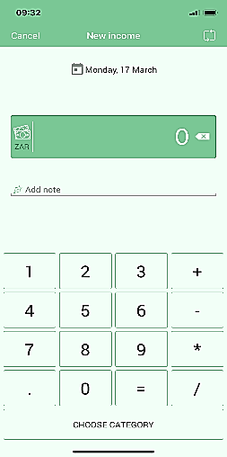

* It also provides good organizations of expenses using categorization.

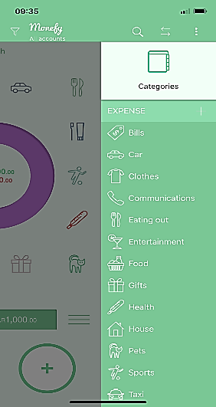

* It shows graphs and pie charts of spending habits, which makes it easier for the user to see where they spend their money.

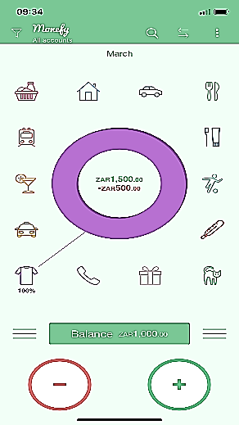

* It also stores data which can also be stored across multiple devices.

* It also has features to set spending limits so that the user can see if they are overspending.

**Strengths and Weaknesses**

Strengths:

* The user-Friendly interface – is one of the appealing features of monefy as it looks good, and it provides graphs so that the user can see their expenses easily.
* The fast transaction entry – is another strength of monefy as the user can add expenses with minimal steps.
* The categorization and visualization – this feature provide a clear categorization using graphs and pie charts showing better financial insights.
* Offline Functionality – this feature is good as the user can track; they expense without internet connection.
* Budgeting Features – this feature allows the user to manage their financial habits as well as set limits so that the user knows when they are overspending.

Weaknesses:

* Limited Free Version – the downside for this is that most of the advanced features are limited to paid versions. Which limits the functionality for free users.
* No Bank Integration – the downside is that there is no bank sync so users will have to manually input transactions.
* Basic Budgeting Features – the downside is that it lacks advanced budgeting tools. In this way it lacks compared to its competitors.
* Limited Customization – the downside to this is that the users cannot fully customize their categories or reports.
* Sync Issues – some user report occasional syncing problems when using cloud backup.

**Innovative Features**

* Lightweight & Offline Functionality – allows the users to track finances whether they have internet access or not, so the user can track their finances anywhere at any time.
* Customizable Time Periods – allows the user to track their finances on any timeframe, allowing flexible finance planning.
* Secure Data Protect – uses passwords and biometrics for enhanced security.
* Multi-Currency Support – this makes it easier for travelers managing finances in different regions.
* One-Tap Expense Tracking – users can instantly add transactions without swapping menus.
* Intuitive Pie Chart Visualization – this makes it easier and more visually engaging for the user for tracking their financial funds.

### Money Manager Expense & Budget

**Overview**

Money Manager Expense & Budget is a personal finance app that allows

users to track daily expenses, manage multiple accounts, and generate

financial reports. It supports transaction categorization, recurring expenses,

and budget monitoring.

Key Features:

Home dashboard:

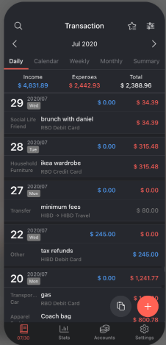

This Displays an overview of income, expenses, and account balances.

Expense Entry Screen:

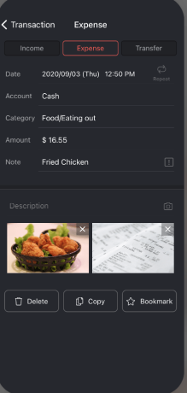

This is where users can input and categorize transactions.

Reports & Graphs:

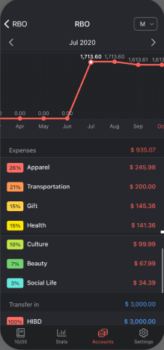

This shows spending trends through visual charts.

Budgeting Section:

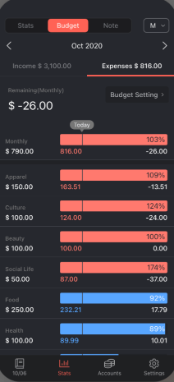

This allows users to set limits for various expense categories.

**Strengths and Weaknesses**

Strengths:

* Intuitive User Interface – The application features a layout that's simple to navigate.
* Thorough Transaction Categorization – Users can allocate expenses to specific categories.
* Automated Recurring Transactions – This feature saves time by automatically recording regular expenses.
* In-Depth Financial Reports – Assists users in examining their spending habits.
* Data Backup and Export Options – Users can secure their financial data by backing it up.

Weaknesses:

* Certain Features are Paid – Enhanced functionalities are restricted to a premium version.
* Absence of Gamification Features – The app does not include engaging elements such as rewards or challenges.
* Old-fashioned UI Design – The interface appears somewhat dated when compared to contemporary finance applications.

**Innovative Features**

* Dual-Entry Accounting System: This feature enables users to effectively monitor both income and expenses, setting it apart from other financial applications.
* Financial Analytics & Charts: Offers users a straightforward representation of their financial status.
* Data Safeguarding & Synchronization: Guarantees that financial information remains secure and available on various devices.

### Harvest

**Overview**

Harvest is a time-tracking and invoicing program made to assist companies with project management, staff time monitoring, and invoicing. Harvest is excellent in many areas, but it lacks capabilities specifically for budgeting.

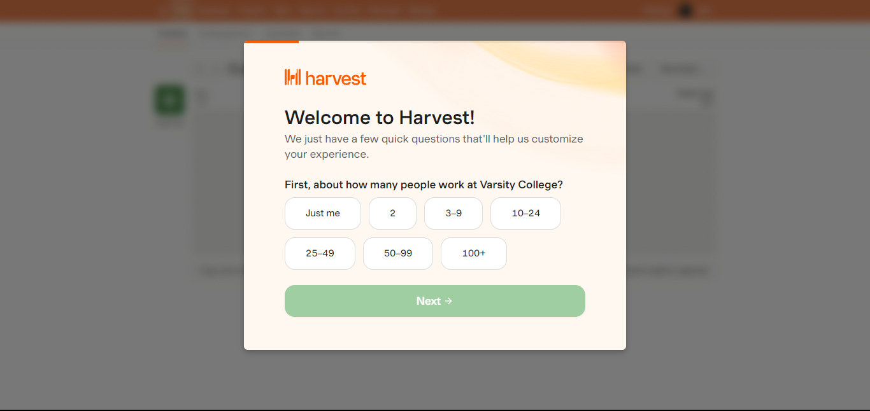

To help the user by figuring out the size of the firm and how much information would need to be recorded; the Harvest app tries to collect information about the company where one works.

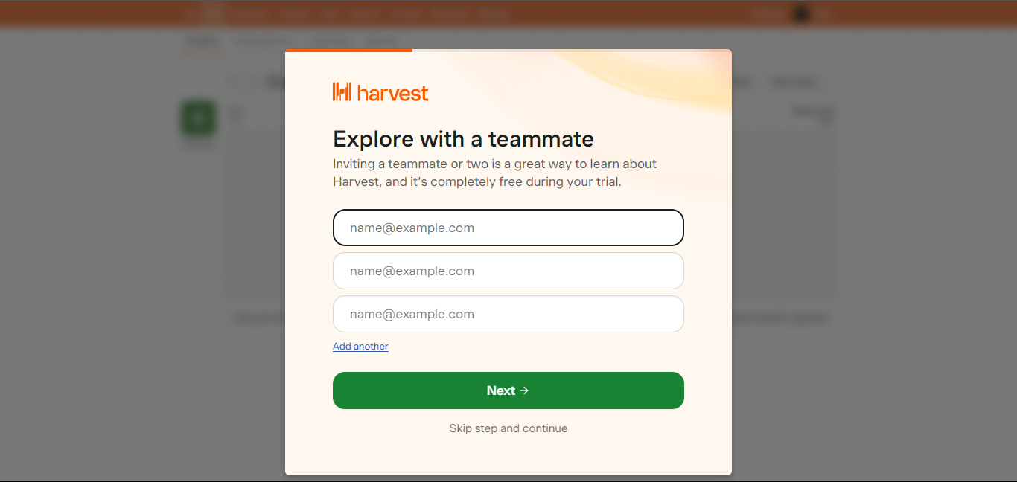

By enabling the user to ask someone to accompany them through the process, the Harvest app fosters teamwork by facilitating resource sharing and encouraging various user inputs.

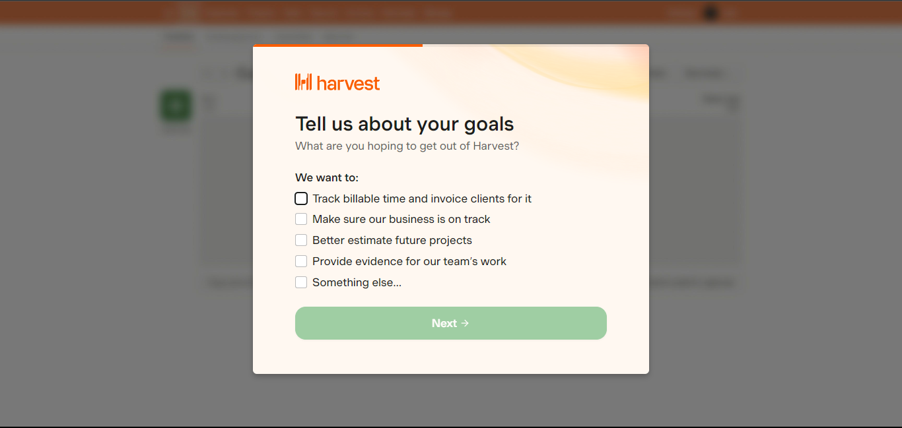

The Harvest app helps the business better focus on its objectives and further reduces the range of data that must be tracked.

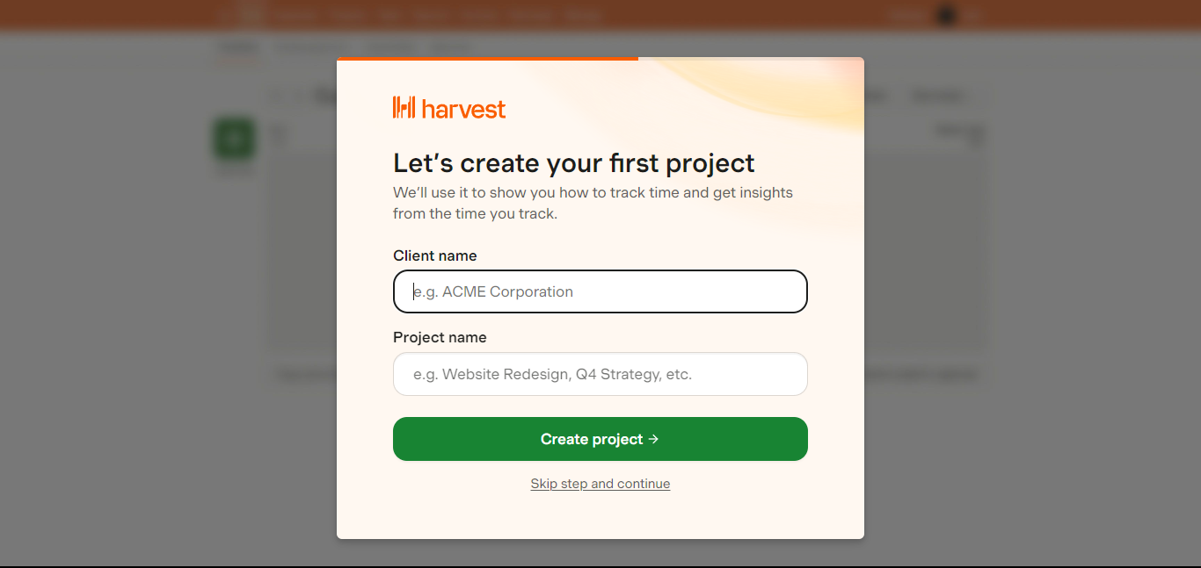

By enabling the user to begin or create a project as soon as they log in, the Harvest app enables users to complete tasks instantly.

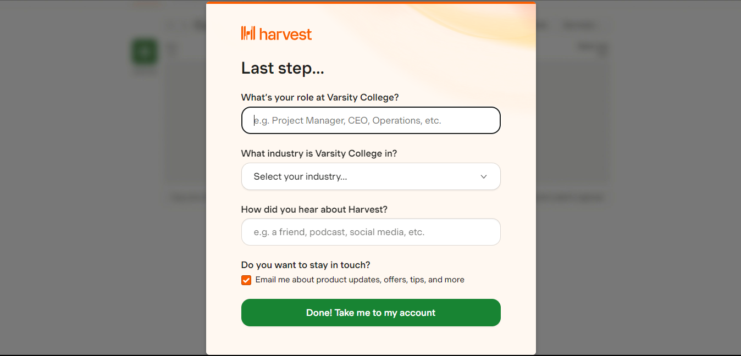

The Harvest app breaks down several positions within an organisation to better show who is responsible for what. To improve goal and resource tracking, the Harvest app lets users enter the field in which the business operates.

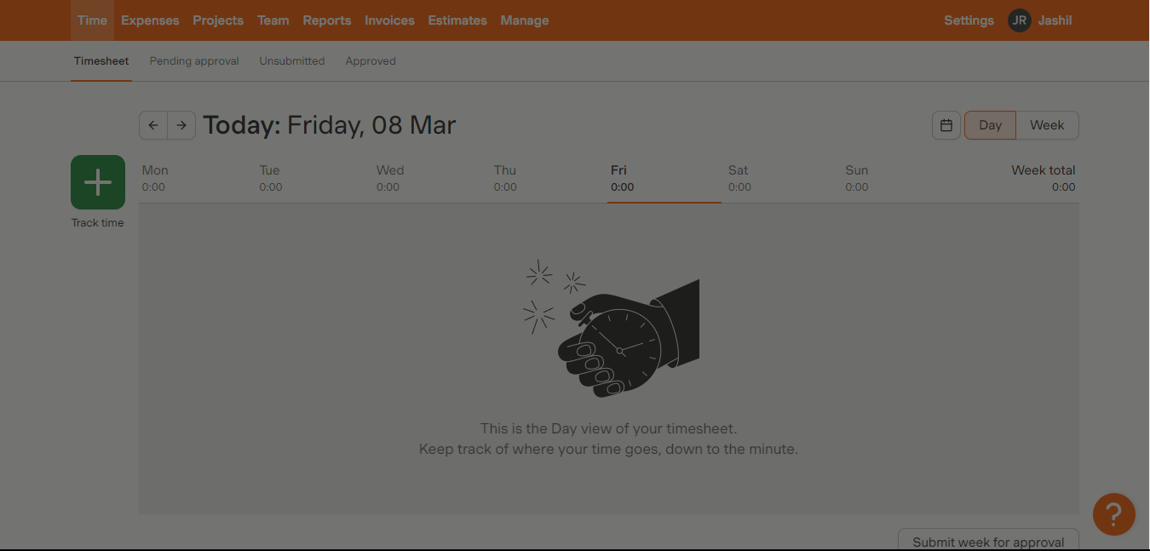

The home screen appears straightforward at first glance and by default displays a daily or weekly schedule, which aids in helping the user concentrate on their daily responsibilities while also allowing them to monitor forthcoming activities that must be completed.

• The user's time spent on tasks is tracked by the first tab, which is a time sheet tab.   
• Since the following tab is for pending approval, it aids the user in monitoring if staff time is being used effectively.   
• The timesheets that have not yet been reviewed or approved are listed on the following tab, which is an unsubmitted tab.   
• The last tab is an authorised tab that contains the timesheets that have been reviewed and approved.

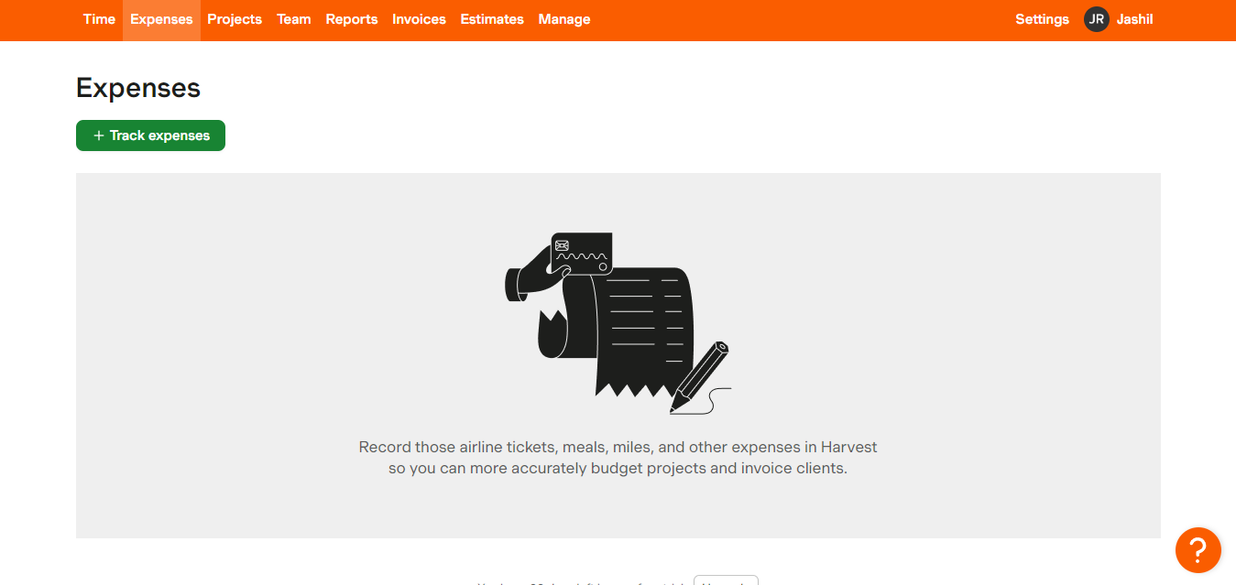

Sorting out financial issues is made easier by the expense tab, which allows the user to keep track of the companies' expenses.

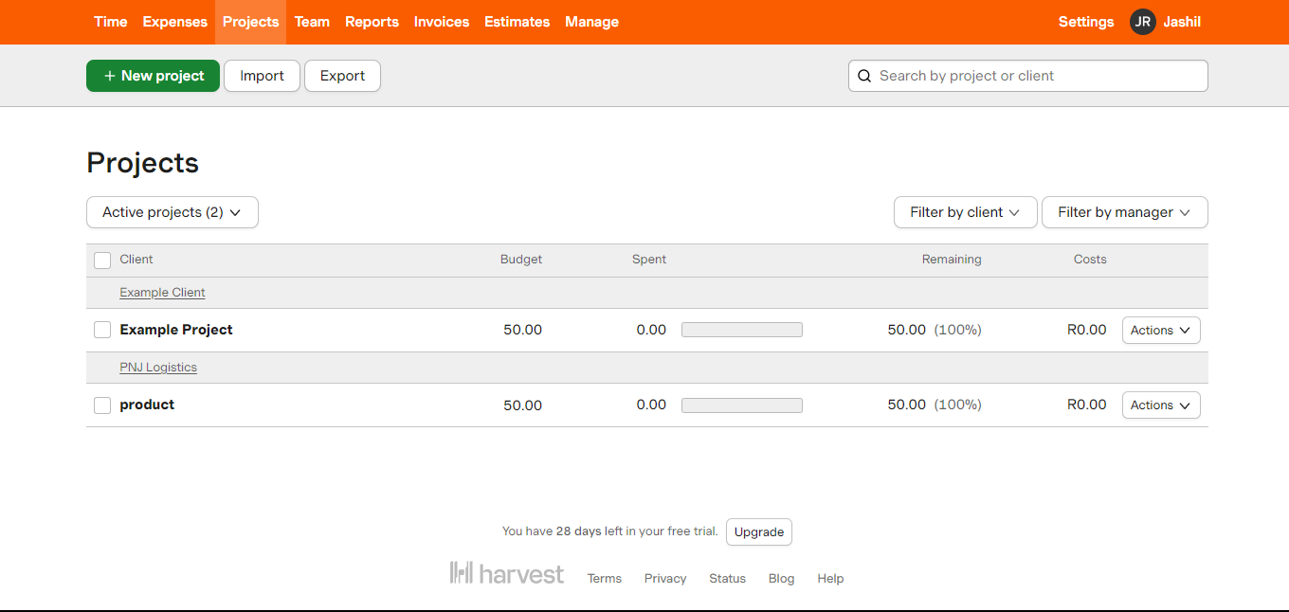

Tracking all the company's projects is made simple by the projects page, which also features a separate tab for establishing new projects, importing projects into the app, and exporting projects to other people.

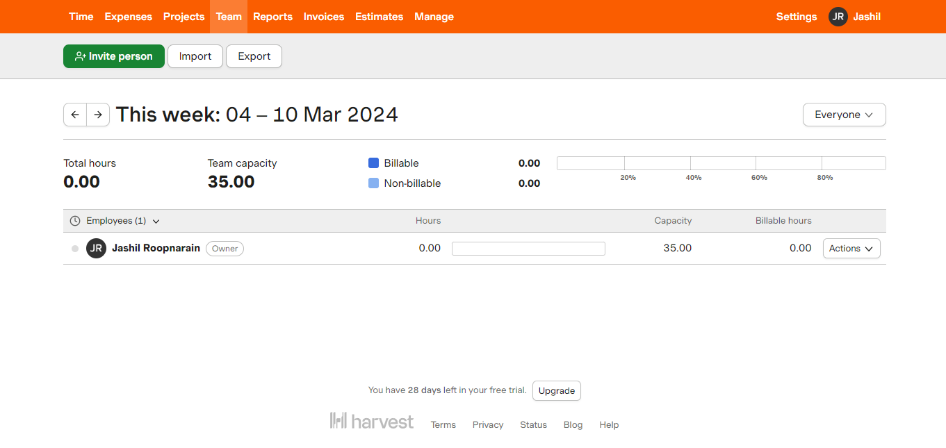

The team tab provides information about each project, including how long it has taken and who has been working on it consistently. It also makes it simple to see who is involved projects.

Harvest timesheets can be accessed by team members using a phone, desktop computer, browser, or paper timesheets, allowing them to log on and record their working hours.   
As the user completes their timesheet, Harvest's Google calendar integration enables them to consult calendar events. (Cruz, 2023)

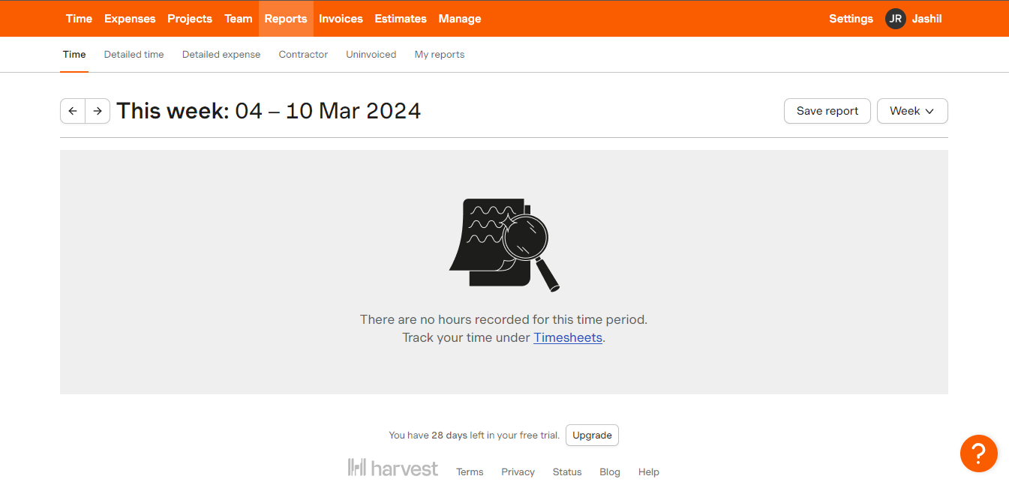

The report tab provides a list of unpaid or unused invoices, a breakdown of the time spent in a general or detailed view, information on the firms involved, and a final breakdown of a customised report for the user.

The reporting feature makes harvest time tracking project management simple and insightful, this is split into four categories:

* Clients
* Tasks
* Teams
* Projects

Each of these categories contains data that shows hours tracked, billable hours, billable amount, and un-invoiced amount. (Cruz, 2023)

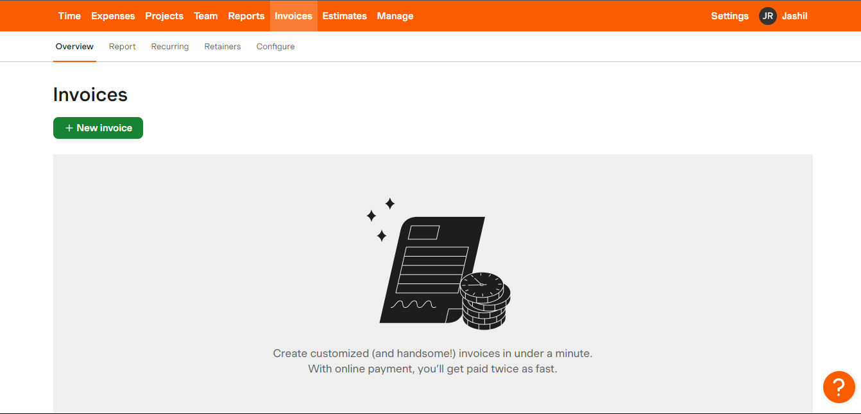

The recuring tab assists in creating frequently used invoices, which are generated automatically; the retainer tab assists in tracking payments made in advance; the invoice tab tracks the company's overview of invoices from or to the company; and the invoice report tab tracks the invoices created and those that have been paid.

You can also use your timesheet and expense monitoring reports to create invoices using the Harvest program. An invoice can be created or set to be generated automatically. Your Harvest account will either automatically send the recurring invoice or save it as a draft for your review. It is also quite simple to email bills. (Cruz, 2023)

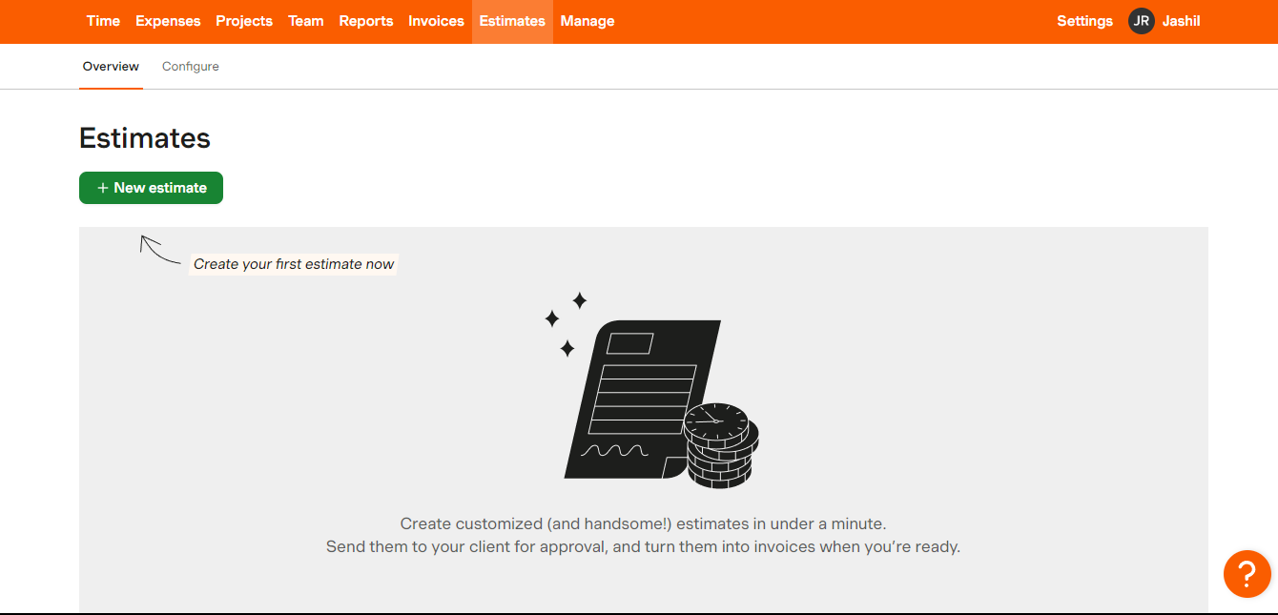

Based on several variables, the estimates tab assists in estimating the price that the business should charge. Once the client gives their approval, the estimates can be turned into an invoice.

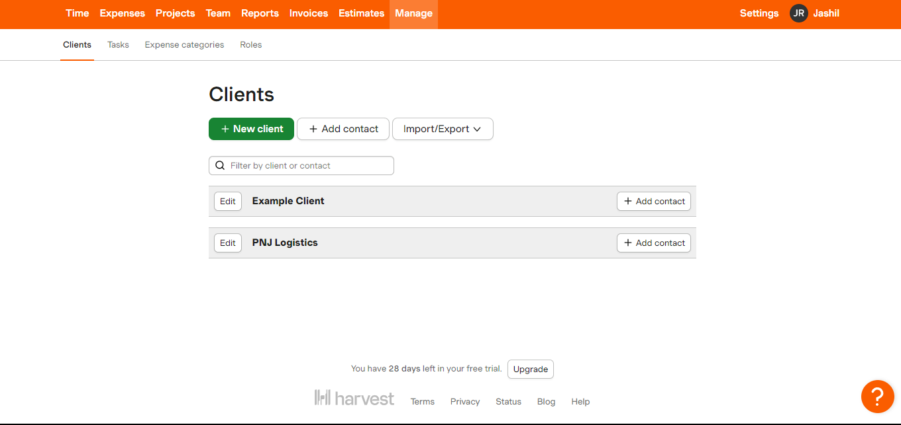

The manage tab facilitates the process of inviting new customers and connections, which may be utilised to make the firm conveniently available to all employees.

**Strengths and Weaknesses**

Strengths:

* Simplicity and Intuitiveness, Pros and cons of harvest 2024 (2023)
* Flexible Time Tracking, Pros and cons of harvest 2024 (2023)
* Accurate Time Tracking, Pros and cons of harvest 2024 (2023)

Weaknesses:

* Certain Features are Paid – Enhanced functionalities are restricted to a premium version.
* Absence of Gamification Features – The app does not include engaging elements such as rewards or challenges.
* Old-fashioned UI Design – The interface appears somewhat dated when compared to contemporary finance applications.

**Innovative Features**

1. Reporting

The reporting feature makes harvest time tracking project management simple and insightful, this is split into four categories:

* Clients
* Tasks
* Teams
* Projects

Each of these categories contains data that shows tracked hours, billable hours, billable amount, and un-invoiced amount. (Cruz, 2023)

1. Timesheet

Harvest timesheets can be accessed by team members using a phone, desktop computer, browser, or paper timesheets, allowing them to log on and record their working hours.   
As the user completes their timesheet, Harvest's Google calendar integration enables them to consult calendar events. (Cruz, 2023)

1. Invoicing

You can also use your timesheet and expense monitoring reports to create invoices using the Harvest program. An invoice can be created or set to be generated automatically. Your Harvest account will either automatically send the recurring invoice or save it as a draft for your review. It is also quite simple to email bills. (Cruz, 2023)

1. Integrations

* Project management
* CRM and communication
* Issue tracking
* Finance and payments
* Contracts and proposals

(Cruz, 2023)

These integrations make the user experience simple as Harvest time tracking app is the only app that needs to be opened and worked on as it ties multiple resources together.

## 3. Budget & Expense Management App Comparison

**1. Overview Section (Icons & Brief Intro)**

* **Monefy**: A personal budgeting app focused on expense tracking.
* **Harvest**: A time tracking and invoicing tool for businesses.
* **General Budgeting App**: A standard finance management tool with diverse features.

**2. Feature Comparison Table**

|  |  |  |  |
| --- | --- | --- | --- |
| **Feature** | **Monefy** | **Harvest** | **General Budgeting App** |
| **Expense Tracking** | **✅** | **✅** | **✅** |
| **Income Tracking** | ❌ | **✅** | **✅** |
| **Time Tracking** | ❌ | **✅** | ❌ |
| **Project Budgeting** | ❌ | **✅** | **✅** |
| **Recurring Transactions** | **✅** | **✅** | **✅** |
| **Bank Integration** | ❌ | ❌ | **✅** |
| **Graphical Reports** | **✅** | **✅** | **✅** |
| **Invoice Generation** | ❌ | **✅** | ❌ |
| **Multi-Device Sync** | **✅** | **✅** | **✅** |
| **Cloud Backup** | **✅** | **✅** | **✅** |
| **Gamification Features** | ❌ | ❌ | **✅** |

**3. Strengths & Weaknesses (Icons & Short Notes)**

* **Monefy**: Great for quick personal expense tracking but lacks bank integration.
* **Harvest**: Excellent for businesses but not a traditional budgeting app.
* **General Budgeting Apps**: Feature-rich but can be complex.

## 4. A list of best Features (will be included in our app)

* One-Tap Expense Tracking (Monefy)
* Multi-Device Synchronization (Monefy)
* Graphs, Budget Limits for Categories (Monefy)
* Customizable Time Periods (Monefy)
* Timesheet (Harvest)
* Invoicing (Harvest)
* Visualized Financial Reports (General Budgeting App)
* Automated Recurring Transactions (General Budgeting App)

## Conclusion

The examination of Monefy, Money Manager Expense & Budget, and Harvest reveals both the advantages and drawbacks of each budgeting application. Monefy is distinguished by its easy-to-use interface, rapid transaction entry, and offline capabilities, making it perfect for those who want a straightforward yet efficient method to monitor their expenses. Nevertheless, its absence of bank integration and limited customization features constrain its utility for users with more complex budgeting requirements.

Money Manager Expense & Budget offers a more comprehensive financial tracking experience with detailed transaction categorization and automated recurring transactions. Its dual-entry accounting system and extensive financial reports provide users with improved financial insights. However, its dated user interface and lack of gamification elements might diminish user engagement when compared to other budgeting applications.

While Harvest is primarily intended for businesses and time tracking, it excels in project management, invoicing, and reporting functionalities. However, it is not specifically tailored for personal budgeting, which renders it less appropriate for individuals looking for expense-tracking solutions.

From this analysis, combining the best features of these applications—such as Monefy’s user-friendly visualizations, Money Manager’s detailed financial reports, and Harvest’s excellent integration capabilities—could lead to the creation of a more all-encompassing budgeting application. By incorporating gamification, automation, and secure multi-device accessibility, a revamped budgeting tool could improve user experience and enhance financial management effectiveness.

# Planning and design

## Introduction

This is planning and the design phase. This will be where we will plan what we will need in the app and there after we will create a mock design. This step is important as it will follow in the footsteps of building our app. In the planning we have an overview with the app’s icon and the name of the app, thereafter we will write a fully detailed list of the requirements this includes the features we will include in our app as well. Then we shall start with the design phase which we will make/get mock images and use it to show how our app will navigate between pages and so on. Thereafter we will have a project plan to set out how we will have to go about completing and on what dates certain things will have to be done.

## Overview

* **App Name: BudgetMate**
* **Tagline:** "Effortless Budgeting, Smarter Finances!"
* **Initial Icon Design:**
* A wallet with a dollar sign and a clipboard

  AI-generated content may be incorrect.
* Colors: **Blue & Green** to signify trust, financial growth, and stability.
* **App Overview:**
* BudgetMate is a feature-rich yet easy-to-use budgeting app designed to help individuals, freelancers, and businesses track expenses, manage invoices, and gain deep financial insights. By combining the best elements from Monefy, Harvest, and general budgeting apps, BudgetMate offers a **holistic** approach to personal and project-based financial management.

## Requirements

Innovative Features:

• One-Tap Expense Tracking – Quickly log transactions with a single tap, making budgeting effortless and timesaving.

• Multi-Device Synchronization – Keep your financial data up to date across all your devices, whether you are using a smartphone, tablet, or desktop.

• Graphs & Visualized Financial Reports – Get clear insights into your spending patterns with interactive graphs, pie charts, and detailed analytics, helping you make smarter financial decisions.

• Budget Limits for Categories – Stay in control of your spending by setting customized limits for different categories, such as groceries, entertainment, and transport. Receive alerts when you are close to exceeding your budget.

• Customizable Time Periods – Track finances the way you prefer daily, weekly, monthly, or even custom time frames to suit your unique budgeting needs.

• Timesheet Tracking – Perfect for freelancers and businesses, this feature tracks billable hours accurately, ensuring efficient time management and seamless invoicing.

• Invoicing for Freelancers & Businesses – Generate professional invoices directly from your tracked work hours and expenses, making it easier to bill clients and get paid faster.

• Automated Recurring Transactions – Automatically log subscriptions, rent, utilities, and other recurring expenses, saving time and reducing manual entry errors.

• Cloud Backup & Data Security – Securely store your financial data on the cloud with automatic backups to prevent loss. Data is encrypted for maximum security.

• Offline Mode – Track your expenses even when you do not have an internet connection. Your data syncs automatically once you are back online.

• Multi-Currency Support – Ideal for travellers and international users, BudgetMate allows seamless tracking of expenses in multiple currencies with real-time exchange rate updates.

• Smart Spending Insights & AI-Powered Budgeting – Get personalized AI-driven recommendations on how to save money, reduce unnecessary spending, and optimize your budget for better financial health.

3)

Core Functional Requirements:

User Accounts & Authentication

• Users must register and create an account via email, phone number, or third-party authentication (Google, Apple, Facebook).

• Implement secure authentication methods such as passwords, OTP verification, and biometric login (fingerprint/face recognition).

• Provide an option for guest mode, where users can use the app without registering but will need to sign in to save data.

• Support multi-device login with synchronized data across devices.

Home Dashboard

• A clean, intuitive dashboard displaying:

• Total income, total expenses, and account balances.

• A summary of spending trends (daily, weekly, monthly, or custom periods).

• A graphical overview of financial health.

• Provide quick access buttons for adding expenses, income, and invoices.

Expense Tracking

• Users must be able to log expenses with one tap.

• Allow categorization of expenses (Food, Rent, Travel, Entertainment, etc.).

• Enable custom categories for personal customization.

• Provide options for adding descriptions, tags, and receipts (image uploads).

• Support multi-currency expenses for travellers.

• Show historical expenses and allow users to filter by date, category, or custom tags.

• Implement AI-powered suggestions to predict and auto-categorize expenses.

Income Tracking

• Users must be able to record multiple income sources (Salary, Freelance, Investments, etc.).

• Allow linking to bank accounts (via secure APIs) to track incoming transactions.

• Provide options for custom income categories.

Budgeting Tools

• Users can set spending limits for different categories.

• Implement alerts and notifications when the user nears or exceeds the budget.

• Provide a goal-based savings system where users can allocate money for specific goals (e.g., vacation, emergency fund).

• Include AI-based budget optimization, giving users suggestions on how to reduce expenses.

Graphs & Reports

• Users must be able to view detailed financial reports including:

• Monthly income vs. expenses comparison.

• Spending breakdown by category (pie charts, bar graphs).

• Weekly and yearly financial trends.

• Provide an interactive dashboard where users can tap on categories to get deeper insights.

• Support data export (CSV, PDF) for external record-keeping.

Multi-Device Synchronization

• Cloud-based data storage allowing real-time synchronization across devices.

• Provide options for manual sync & auto-sync with cloud storage options (Google Drive, Dropbox).

Invoicing for Freelancers & Businesses

• Users can create professional invoices with customizable templates.

• Allow users to add a company logo, payment details, and custom fields.

• Provide options to send invoices via email or share via link.

• Integrate with payment gateways (PayPal, Stripe, Bank Transfers) for online payments.

• Users can track paid and unpaid invoices and set reminders for due payments.

Recurring Transactions & Bill Reminders

• Users can set up automated recurring expenses (rent, subscriptions, loan payments).

• Implement reminders and notifications for upcoming bills.

• Allow users to cancel or modify recurring payments.

Gamification & Financial Challenges

• Introduce a gamified experience to make budgeting fun:

• Savings Streaks – Encourage users to maintain a streak of saving money.

• Budget Challenges – Users can set personal or community-based challenges (e.g., “Save $200 this month”).

• Reward Badges – Unlock achievements for smart spending habits.

• Include a leaderboard where users can compare their savings with friends.

• Reward System for Smart Budgeting

• Users earn points & badges for staying within budget.

• Points can be redeemed for premium features or financial coaching tips.

Security & Data Protection

• Implement end-to-end encryption for user financial data.

• Allow two-factor authentication (2FA) for additional security.

• Support biometric authentication (fingerprint, Face ID).

• Ensure GDPR & data privacy compliance.

Technical & System Requirements:

Platforms & Compatibility

• Mobile App: Android (min. version 8.0), iOS (min. version 12.0).

• Web Dashboard: Responsive design for desktop and mobile browsers.

• API Support: REST API for third-party integrations.

Tech Stack

• Frontend: React Native (for cross-platform mobile apps).

• Backend: Node.js + Express.js (for handling transactions & user data).

• Database: Firebase / PostgreSQL (secure cloud storage & syncing).

• Payment Gateway: Stripe, PayPal API (for invoicing & payments).

• Authentication: Firebase Auth / OAuth (for secure login).

Integrations

• Bank APIs (Plaid, Yodlee) for automatic transaction tracking.

• Cloud Storage (Google Drive, Dropbox) for data backup.

• Accounting Software (QuickBooks, Xero) for business users.

• Notification Services (Firebase Cloud Messaging) for reminders & alerts.

User Experience & UI/UX Guidelines

• Simple & Clean UI: Minimalist design with easy navigation.

• Dark Mode Support: Users can switch between light & dark themes.

• Drag & Drop Interface: For customizing budget categories.

• One-Tap Transactions: Quick expense logging without unnecessary steps.

• Personalized Dashboard: Users can customize widgets & graphs.

Monetization & Pricing Model:

Free Version

• Basic expense tracking

• Budgeting tools

• Reports & Graphs

• Cloud sync (limited)

Premium Subscription (Monthly/Yearly Plan)

• Unlimited cloud sync

• AI-powered budgeting insights

• Multi-currency & bank integration

Advanced invoice & expense reports

• Gamification challenges & leaderboards

One-Time Purchases

• Custom Invoice Templates – Purchase premium invoice designs.

• Financial Coaching Tools – AI-powered financial recommendations.

## User interface design

Figure : The login page allows the user to securely login using the username and password, if they don’t have an account they click create an account button, to create an account.

Figure : The settings page allows the user to change their preferences for their app or logout using the logout button

Figure : The expense tracker allows the user to track their expenses and allows the user to add their expenses using the add expense button.

Figure : The invoice and receipt page allow the user to generate receipt by filling out the need information.

Figure : This is the accounts page which allows the users to manage their profile/account.

Figure : This is the home page which provides navigations to the other pages.

Figure : This is the income page where the users can add their income and track their income.

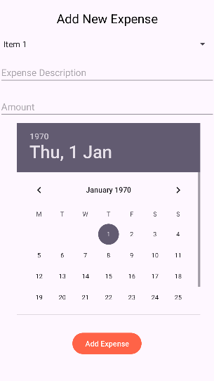

Figure : This is where you can add you expenses it allows you to pick the dates, enter the amount, and input a description.

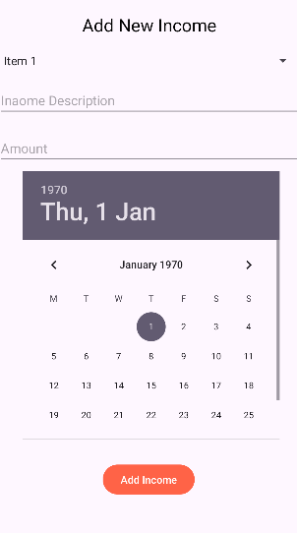

Figure : This is where you can add your Income. It allows you to pick the dates, enter the amount, and input a description.

## Project Plan

Overview

The Personal Budget Tracker App follows the Research - Plan - Design - Build - Evaluate cycle. The project is structured with clear tasks, deadlines, and milestones, ensuring smooth development and completion by May 2 for Part 2.

The project plan includes:

A breakdown of key tasks into manageable sections.

Time allocation for testing and debugging to ensure quality.

A Gantt chart that visually represents the timeline.

Project Timeline & Milestones

|  |  |  |  |  |
| --- | --- | --- | --- | --- |
| **Phase** | **Tasks** | **Start Date** | **End Date** | **Duration** |
| **Research** | - Analyze existing budgeting apps  - Identify key features | **March 11** | **March 18** | **1 week** |
| **Planning** | - Define app requirements  - Finalize innovative features | **March 19** | **March 22** | **4 days** |
| **Design** | - Create wireframes/mockups for all screens  - Plan UI/UX design and user flow | **March 23** | **March 30** | **1 week** |
| **Development (Part 1)** | - Build database structure  - Implement basic features:   * Income and expense tracking   * Budgeting and financial goals | **March 31** | **April 14** | **2 weeks** |
| **Development (Part 2)** | - Implement advanced features:   * Reports and statistics   * Gamification elements (rewards, progress tracking, streaks) | **April 15** | **April 25** | **1.5 weeks** |
| **Testing & Debugging** | - Conduct user testing  - Fix critical bugs  - Optimize performance | **April 26** | **May 1** | **6 days** |
| **Submission (Part 2)** | - Complete documentation  - Submit the project | **May 2** | **May 2** | **1 day** |

Gantt Chart Representation

|  |  |  |  |  |  |  |  |
| --- | --- | --- | --- | --- | --- | --- | --- |
| **Task** | **March 11 - 18** | **March 19 - 22** | **March 23 - 30** | **Mar 31 - Apr 14** | **Apr 15 - 25** | **Apr 26 - May 1** | **May 2** |
| Research | ████████ |  |  |  |  |  |  |
| Planning |  | ████ |  |  |  |  |  |
| Design |  |  | ████████ |  |  |  |  |
| Development (P1) |  |  |  | ████████████ |  |  |  |
| Development (P2) |  |  |  |  | ████████ |  |  |
| Testing & Debugging |  |  |  |  |  | ████████ |  |
| Submission |  |  |  |  |  |  | █ |

## Conclusion

An overview of the project

Through gamification, the Personal Budget Tracker App aims to make budgeting fun while assisting users in managing their income, expenses, and savings. The project adheres to a methodical Research-Plan-Design-Build-Evaluate process, guaranteeing a well-structured and superior product.

key points

* Effective Expense Tracking: This method makes it simple to track and classify spending.
* Financial Goals & Budgeting: Assists users in establishing and overseeing financial objectives.
* Gamification: Promotes participation via progress monitoring and rewards.
* Secure Cloud Database: Provides data security and accessibility across several devices.
* Reports and Analytics: Offers information to help with financial awareness.
* final thoughts

With organized work, thorough testing, and time for documentation, the updated project plan guarantees that Part 2 will be finished by May 2. All essential functionalities will be included in the final submission, along with enhancements derived from user testing.

# References

* Realbyte Inc. (Google Play Store Listing): <https://www.realbyteapps.com/>
* Google play store/ App store: user reviews
* Financial App Comparison Blogs: <https://www.pcmag.com/picks/the-best-personal-finance-services?test_uuid=06VbILP0gGfqWI6STznyr7F&test_variant=A>
* <https://www.google.com/search?q=money+manager+expense+%26+budget+review&rlz=1C1CHBF_enZA987ZA987&oq=Money+Manager+Expense+%26+Budget+&gs_lcrp=EgZjaHJvbWUqDQgEEAAYkQIYgAQYigUyBggAEEUYOTIICAEQRRgnGDsyCAgCEEUYJxg7MgYIAxBFGEAyDQgEEAAYkQIYgAQYigUyDQgFEAAYkQIYgAQYigUyBggGEEUYPDIGCAcQRRg90gEIMjkyNmowajeoAgiwAgHxBaj9iu5DQUSb&sourceid=chrome&ie=UTF-8>
* <https://www.getapp.com/p/sem/budgeting-software/?t=Top%20Budgeting%20Software/&camp=adw_search&utm_source=ps-google&utm_medium=cpc&account_campaign_id=22316746979&account_adgroup_id=181724650768&ad_id=737376431915&utm_term=best%20budget%20app&matchtype=b&utm_campaign=:1:GA:2:COM:3:All:4:INTL-T2:5:BAU:6:SOF:7:Mobile:8:All:9:Budgeting&network=g&gad_source=1&gbraid=0AAAAAocz2xXg-xOrAUxw77JuqvxxSzhqc&gclid=Cj0KCQjw1um-BhDtARIsABjU5x6inP_Si-tqskUvJYwp60p-clyNa9daJ-tlTRqAx1dvuMlGwHwG_WMaAvsJEALw_wcB>
* <https://www.nerdwallet.com/article/finance/best-budget-apps>
* <https://www.forbes.com/advisor/banking/best-budgeting-apps/>
* Pros and cons of harvest 2024 (2023) TrustRadius. Available at: <https://www.trustradius.com/products/harvest/reviews?qs=pros-and-cons#reviews> (Accessed: 10 March 2025).
* Cruz, L. (2023) Harvest Time Tracking Guide (features, Pros, limitations), ClickUp. Available at: <https://clickup.com/blog/harvest-time-tracking/?utm_source=gpm&utm_medium=cpc&utm_campaign=gpm_cpc_ar_nnc_pro_trial_all-devices_tcpa_lp_x_all-departments_x_pmax&utm_content=&utm_term=&utm_creative=_____&gad_source=1&gclid=CjwKCAiA0bWvBhBjEiwAtEsoW47WLOk-rAEoS9qxi_DL2sLdupclg4lGRE-ayOVtSid8jPDwa_LKSxoCUy0QAvD_BwE> (Accessed: 10 March 2025).
* Chen, S. & Rasmussen, J. (2022) ‘The role of AI in personal finance management apps: Trends & predictions’, Financial Tech Journal, 18(3), pp. 45-67.
* Duolingo-Inspired Gamification for Finance (2021) GamificationHub. Available at: <https://www.gamificationhub.com/> (Accessed: 12 March 2025).
* Hamari, J., Koivisto, J. & Sarsa, H. (2014) ‘Does gamification work? A literature review of empirical studies on gamification’, Proceedings of the 47th Hawaii International Conference on System Sciences, pp. 3025-3034.
* Harvest (n.d.) Time tracking & invoicing platform. Available at: <https://www.getharvest.com/> (Accessed: 12 March 2025).
* KPMG (2023) AI in banking & finance report. Available at: <https://home.kpmg/> (Accessed: 12 March 2025).
* Mint (n.d.) Budgeting & money management. Available at: <https://www.mint.com/> (Accessed: 12 March 2025).
* Monefy (n.d.) Expense tracker app. Available at: <https://www.monefy.me/> (Accessed: 12 March 2025).
* PocketGuard (n.d.) Personal finance app. Available at: <https://pocketguard.com/> (Accessed: 12 March 2025).
* YNAB (n.d.) You Need A Budget. Available at: <https://www.ynab.com/> (Accessed: 12 March 2025).
* Monefy - Top Ten Important Things You Need To Know, DotCom Magazine-Influencers And Entrepreneurs Making News, [Online]<https://dotcommagazine.com/2023/07/monefy-top-ten-important-things-you-need-to-know/#:~:text=Monefy%20is%20a%20popular%20personal%20finance%20management%20application,gain%20a%20comprehensive%20understanding%20of%20their%20financial%20situation>. , [accessed: 2025-03-20]
* Monefy App, Monefy App Tutorial - How to use synchronization, recurring transactions, passcode, categories, YouTube, 2020-10-14, 00:12:19, <https://www.youtube.com/watch?v=SawLuRfo0J8> , [accessed: 2025-03-20]